Exercise 1: Implementing the Singleton Pattern
Code:
using System;
using System.Threading.Tasks; // Add this line for Parallel class

namespace SingletonPatternExample
{
// Singleton Logger class
public sealed class Logger
{
// Private static instance
private static Logger _instance = null;

// Lock object for thread safety
private static readonly object _lock = new object();

// Private constructor
private Logger()
{
Console.WriteLine("Logger instance created");
}

// Public static property to access the instance
public static Logger Instance
{
get
{
// Double-check locking for thread safety
if (_instance == null)
{
lock (_lock)
{
if (_instance == null)
{
_instance = new Logger();
}
}
}
return _instance;
}
}

// Log method
public void Log(string message)
{
Console.WriteLine($"[{DateTime.Now:yyyy-MM-dd HH:mm:ss}] {message}");
}
}
// Test class
class Program
{
static void Main(string[] args)
{
Console.WriteLine("Singleton Pattern Demo");
Console.WriteLine("----------------------");

// Get first instance
Logger logger1 = Logger.Instance;
logger1.Log("First log message");

// Get second instance
Logger logger2 = Logger.Instance;
logger2.Log("Second log message");

// Verify both references point to same instance
Console.WriteLine($"\nAre logger1 and logger2 the same instance? {logger1 == logger2}");

// Test thread safety
Console.WriteLine("\nTesting thread safety...");
Parallel.Invoke(
() => {
Logger logger3 = Logger.Instance;
logger3.Log("Message from thread 1");
},
() => {
Logger logger4 = Logger.Instance;
logger4.Log("Message from thread 2");
}
);

Console.WriteLine("\nPress any key to exit...");
Console.ReadKey();
}
}
}

Output:
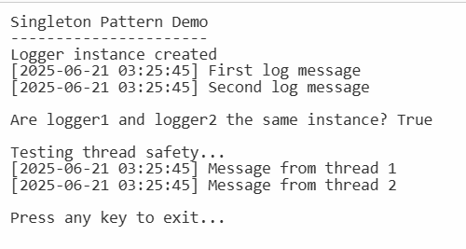

Exercise 2: Implementing the Factory Method Pattern
Codes:
using System;

// Step 2: Define Document Classes
public interface IDocument
{
void Open();
}
// Step 3: Create Concrete Document Classes
public class WordDocument : IDocument
{
public void Open()
{
Console.WriteLine("Opening a Word document.");
}
}
public class PdfDocument : IDocument
{
public void Open()
{
Console.WriteLine("Opening a PDF document.");
}
}
public class ExcelDocument : IDocument
{
public void Open()
{
Console.WriteLine("Opening an Excel document.");
}
}
// Step 4: Implement the Factory Method
public abstract class DocumentFactory
{
public abstract IDocument CreateDocument();
}
public class WordDocumentFactory : DocumentFactory
{
public override IDocument CreateDocument()
{
return new WordDocument();
}
}
public class PdfDocumentFactory : DocumentFactory
{
public override IDocument CreateDocument()
{
return new PdfDocument();
}
}
public class ExcelDocumentFactory : DocumentFactory
{
public override IDocument CreateDocument()
{
return new ExcelDocument();
}
}
// Step 5: Test the Factory Method Implementation
class Program
{
static void Main(string[] args)
{
Console.WriteLine("Factory Method Pattern Demo");
Console.WriteLine("---------------------------");
// Create a Word document
DocumentFactory wordFactory = new WordDocumentFactory();
IDocument wordDoc = wordFactory.CreateDocument();
wordDoc.Open();
// Create a PDF document
DocumentFactory pdfFactory = new PdfDocumentFactory();
IDocument pdfDoc = pdfFactory.CreateDocument();
pdfDoc.Open();
// Create an Excel document
DocumentFactory excelFactory = new ExcelDocumentFactory();
IDocument excelDoc = excelFactory.CreateDocument();
excelDoc.Open();
Console.WriteLine("\nPress any key to exit...");
Console.ReadKey();
}
}

Output:
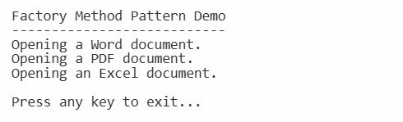

Exercise 3: Implementing the Builder Pattern
Codes:
using System;

// Step 2: Define a Product Class
public class Computer
{
// Attributes of the Computer class
public string CPU { get; private set; }
public string RAM { get; private set; }
public string Storage { get; private set; }
public string GPU { get; private set; }
public string OS { get; private set; }
// Private constructor that takes the Builder as a parameter
private Computer(Builder builder)
{
CPU = builder.CPU;
RAM = builder.RAM;
Storage = builder.Storage;
GPU = builder.GPU;
OS = builder.OS;
}
// Step 3: Implement the Builder Class
public class Builder
{
// Optional parameters with default values
public string CPU { get; private set; } = "Default CPU";
public string RAM { get; private set; } = "8GB";
public string Storage { get; private set; } = "256GB SSD";
public string GPU { get; private set; } = "Integrated Graphics";
public string OS { get; private set; } = "Windows 10";
// Methods to set each attribute
public Builder SetCPU(string cpu)
{
CPU = cpu;
return this;
}
public Builder SetRAM(string ram)
{
RAM = ram;
return this;
}
public Builder SetStorage(string storage)
{
Storage = storage;
return this;
}
public Builder SetGPU(string gpu)
{
GPU = gpu;
return this;
}
public Builder SetOS(string os)
{
OS = os;
return this;
}
// Build method that returns an instance of Computer
public Computer Build()
{
return new Computer(this);
}
}

// Override ToString for easy display of Computer details
public override string ToString()
{
return $"Computer Specifications:\n" +
$"CPU: {CPU}\n" +
$"RAM: {RAM}\n" +
$"Storage: {Storage}\n" +
$"GPU: {GPU}\n" +
$"OS: {OS}";
}
}
// Step 5: Test the Builder Implementation
class Program
{
static void Main(string[] args)
{
Console.WriteLine("Builder Pattern Demo");
Console.WriteLine("---------------------");
// Create a Computer using the Builder pattern
Computer gamingPC = new Computer.Builder()
.SetCPU("Intel i9")
.SetRAM("32GB")
.SetStorage("1TB SSD")
.SetGPU("NVIDIA RTX 3080")
.SetOS("Windows 11")
.Build();
Console.WriteLine(gamingPC);
// Create another Computer with different configuration
Computer officePC = new Computer.Builder()
.SetCPU("AMD Ryzen 5")
.SetRAM("16GB")
.SetStorage("512GB SSD")
.SetOS("Windows 10")
.Build();
Console.WriteLine("\n" + officePC);
Console.WriteLine("\nPress any key to exit...");
Console.ReadKey();
}
}

Output:
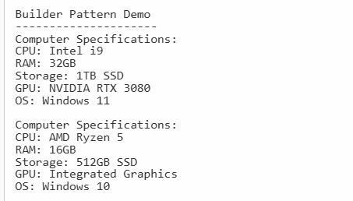
Exercise 4: Implementing the Adapter Pattern
Codes:
using System;

// Step 2: Define Target Interface
public interface IPaymentProcessor
{
void ProcessPayment(decimal amount);
}
// Step 3: Implement Adaptee Classes (Different Payment Gateways with their own APIs)
public class PayPalGateway
{
public void PayWithPayPal(decimal amount)
{
Console.WriteLine($"Processing payment of ${amount} through PayPal.");
}
}
public class StripeGateway
{
public void MakeStripePayment(decimal amountInCents)
{
Console.WriteLine($"Processing payment of ${amountInCents / 100m} through Stripe.");
}
}
public class SquareGateway
{
public void SquarePay(double amount)
{
Console.WriteLine($"Processing payment of ${amount} through Square.");
}
}
// Step 4: Implement Adapter Classes
public class PayPalAdapter : IPaymentProcessor
{
private readonly PayPalGateway _payPalGateway;
public PayPalAdapter(PayPalGateway payPalGateway)
{
_payPalGateway = payPalGateway;
}
public void ProcessPayment(decimal amount)
{
_payPalGateway.PayWithPayPal(amount);
}
}
public class StripeAdapter : IPaymentProcessor
{
private readonly StripeGateway _stripeGateway;
public StripeAdapter(StripeGateway stripeGateway)
{
_stripeGateway = stripeGateway;
}
public void ProcessPayment(decimal amount)
{
// Stripe expects amount in cents as int
int amountInCents = (int)(amount * 100);
_stripeGateway.MakeStripePayment(amountInCents);
}
}
public class SquareAdapter : IPaymentProcessor
{
private readonly SquareGateway _squareGateway;
public SquareAdapter(SquareGateway squareGateway)
{
_squareGateway = squareGateway;
}
public void ProcessPayment(decimal amount)
{
// Square accepts double
_squareGateway.SquarePay((double)amount);
}
}
// Step 5: Test the Adapter Implementation
class Program
{
static void Main(string[] args)
{
decimal paymentAmount = 100.50m;
IPaymentProcessor paypalProcessor = new PayPalAdapter(new PayPalGateway());
IPaymentProcessor stripeProcessor = new StripeAdapter(new StripeGateway());
IPaymentProcessor squareProcessor = new SquareAdapter(new SquareGateway());
Console.WriteLine("Using PayPal Adapter:");
paypalProcessor.ProcessPayment(paymentAmount);
Console.WriteLine("\nUsing Stripe Adapter:");
stripeProcessor.ProcessPayment(paymentAmount);
Console.WriteLine("\nUsing Square Adapter:");
squareProcessor.ProcessPayment(paymentAmount);
}
}
Output:
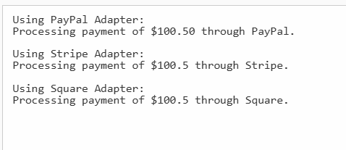

Exercise 5: Implementing the Decorator Pattern
Codes:
using System;

// Step 2: Define Component Interface
public interface INotifier
{
void Send(string message);
}
// Step 3: Implement Concrete Component
public class EmailNotifier : INotifier
{
public void Send(string message)
{
Console.WriteLine($"Sending Email Notification: {message}");
}
}
// Step 4: Implement Decorator Classes
// Abstract Decorator Class
public abstract class NotifierDecorator : INotifier
{
protected INotifier _wrappee;
public NotifierDecorator(INotifier notifier)
{
_wrappee = notifier;
}
public virtual void Send(string message)
{
_wrappee.Send(message);
}
}
// Concrete Decorator - SMS
public class SMSNotifierDecorator : NotifierDecorator
{
public SMSNotifierDecorator(INotifier notifier) : base(notifier) { }
public override void Send(string message)
{
base.Send(message); // send notification via wrapped notifier
SendSMS(message); // add SMS notification
}
private void SendSMS(string message)
{
Console.WriteLine($"Sending SMS Notification: {message}");
}
}
// Concrete Decorator - Slack
public class SlackNotifierDecorator : NotifierDecorator
{
public SlackNotifierDecorator(INotifier notifier) : base(notifier) { }
public override void Send(string message)
{
base.Send(message); // send notification via wrapped notifier
SendSlack(message); // add Slack notification
}
private void SendSlack(string message)
{
Console.WriteLine($"Sending Slack Notification: {message}");
}
}
// Step 5: Test the Decorator Implementation
class Program
{
static void Main(string[] args)
{
string message = "This is a test notification.";
// Base notifier - only Email
INotifier emailNotifier = new EmailNotifier();
Console.WriteLine("Email only:");
emailNotifier.Send(message);
Console.WriteLine("\nEmail + SMS:");
// Email + SMS
INotifier emailAndSmsNotifier = new SMSNotifierDecorator(emailNotifier);
emailAndSmsNotifier.Send(message);
Console.WriteLine("\nEmail + SMS + Slack:");
// Email + SMS + Slack
INotifier emailSmsSlackNotifier = new SlackNotifierDecorator(emailAndSmsNotifier);
emailSmsSlackNotifier.Send(message);
}
}

Output:
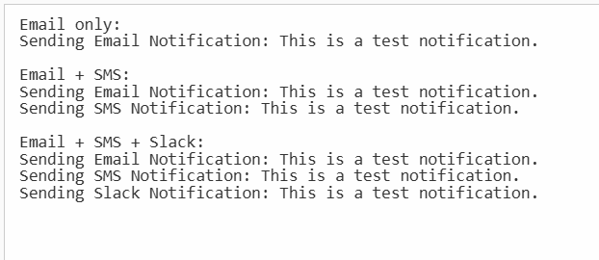

Exercise 6: Implementing the Proxy Pattern
Codes:
using System;

// Step 2: Define Subject Interface
public interface IImage
{
void Display();
}
// Step 3: Implement Real Subject Class
public class RealImage : IImage
{
private string _fileName;
public RealImage(string fileName)
{
_fileName = fileName;
LoadFromRemoteServer(_fileName);
}
private void LoadFromRemoteServer(string fileName)
{
Console.WriteLine($"Loading image '{fileName}' from remote server...");
// Simulate delay for loading
System.Threading.Thread.Sleep(1000);
}
public void Display()
{
Console.WriteLine($"Displaying image '{_fileName}'.");
}
}
// Step 4: Implement Proxy Class
public class ProxyImage : IImage
{
private RealImage _realImage;
private string _fileName;
public ProxyImage(string fileName)
{
_fileName = fileName;
}
public void Display()
{
// Lazy initialization: only load when needed
if (_realImage == null)
{
_realImage = new RealImage(_fileName);
}
else
{
Console.WriteLine($"Using cached image '{_fileName}'.");
}
_realImage.Display();
}
}
// Step 5: Test Proxy Implementation
class Program
{
static void Main(string[] args)
{
IImage image1 = new ProxyImage("photo1.jpg");
IImage image2 = new ProxyImage("photo2.jpg");
// Image loads only on first display call
image1.Display();
Console.WriteLine();

// Second call uses cached image - no loading delay
image1.Display();
Console.WriteLine();
// Load second image
image2.Display();
Console.WriteLine();
// Cached second image display
image2.Display();
}
}

Output:
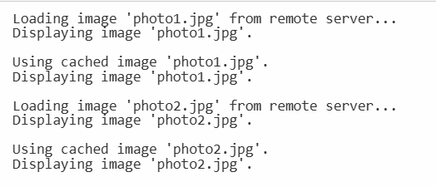

Exercise 7: Implementing the Observer Pattern
Codes:
using System;
using System.Collections.Generic;

// Step 2: Define Subject Interface
public interface IStock
{
void RegisterObserver(IObserver observer);
void RemoveObserver(IObserver observer);
void NotifyObservers();
}
// Step 4: Define Observer Interface
public interface IObserver
{
void Update(decimal price);
}
// Step 3: Implement Concrete Subject
public class StockMarket : IStock
{
private List<IObserver> observers = new List<IObserver>();
private decimal _stockPrice;
public decimal StockPrice
{
get => _stockPrice;
set
{
_stockPrice = value;
NotifyObservers();
}
}
public void RegisterObserver(IObserver observer)
{
if (!observers.Contains(observer))
observers.Add(observer);
}
public void RemoveObserver(IObserver observer)
{
if (observers.Contains(observer))
observers.Remove(observer);
}
public void NotifyObservers()
{
foreach (var observer in observers)
{
observer.Update(_stockPrice);
}
}
}
// Step 5: Implement Concrete Observers
public class MobileApp : IObserver
{
private string _appName;
public MobileApp(string appName)
{
_appName = appName;
}
public void Update(decimal price)
{
Console.WriteLine($"MobileApp {_appName} received stock price update: ${price}");
}
}

public class WebApp : IObserver
{
private string _websiteName;
public WebApp(string websiteName)
{
_websiteName = websiteName;
}
public void Update(decimal price)
{
Console.WriteLine($"WebApp {_websiteName} received stock price update: ${price}");
}
}
// Step 6: Test the Observer Implementation
class Program
{
static void Main(string[] args)
{
StockMarket stockMarket = new StockMarket();
IObserver mobileApp1 = new MobileApp("MobileAppOne");
IObserver mobileApp2 = new MobileApp("MobileAppTwo");
IObserver webApp = new WebApp("FinanceWeb");
stockMarket.RegisterObserver(mobileApp1);
stockMarket.RegisterObserver(mobileApp2);
stockMarket.RegisterObserver(webApp);
Console.WriteLine("Updating stock price to 150.75");
stockMarket.StockPrice = 150.75m;
Console.WriteLine("\nRemoving MobileAppTwo observer");
stockMarket.RemoveObserver(mobileApp2);
Console.WriteLine("\nUpdating stock price to 155.00");
stockMarket.StockPrice = 155.00m;
}
}

Output:
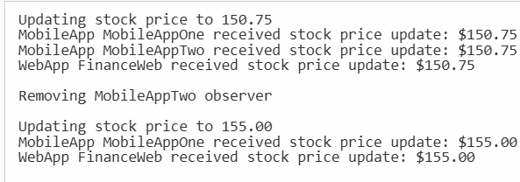

Exercise 8: Implementing the Strategy Pattern
Codes:
using System;

namespace StrategyPatternExample
{
// Step 1: Define Strategy Interface
public interface IPaymentStrategy
{
void Pay(decimal amount);
}
// Step 2: Implement Concrete Strategies
public class CreditCardPayment : IPaymentStrategy
{
private string _cardNumber;
public CreditCardPayment(string cardNumber)
{
_cardNumber = cardNumber;
}
public void Pay(decimal amount)
{
Console.WriteLine($"Paid {amount:C} using Credit Card: {_cardNumber}");
}
}
public class PayPalPayment : IPaymentStrategy
{
private string _email;
public PayPalPayment(string email)
{
_email = email;
}
public void Pay(decimal amount)
{
Console.WriteLine($"Paid {amount:C} using PayPal account: {_email}");
}
}
// Step 3: Implement Context Class
public class PaymentContext
{
private IPaymentStrategy _paymentStrategy;
public void SetPaymentStrategy(IPaymentStrategy paymentStrategy)
{
_paymentStrategy = paymentStrategy;
}
public void ExecutePayment(decimal amount)
{
if (_paymentStrategy == null)
{
Console.WriteLine("Payment strategy not set.");
return;
}
_paymentStrategy.Pay(amount);
}
}
// Step 4: Test the Strategy Implementation
class Program
{
static void Main(string[] args)
{
PaymentContext paymentContext = new PaymentContext();
// Using Credit Card Payment
paymentContext.SetPaymentStrategy(new CreditCardPayment("1234-5678-9012-3456"));
paymentContext.ExecutePayment(100.00m);

// Using PayPal Payment
paymentContext.SetPaymentStrategy(new PayPalPayment("user@example.com"));
paymentContext.ExecutePayment(200.00m);
// Attempting to execute payment without setting a strategy
paymentContext.SetPaymentStrategy(null);
paymentContext.ExecutePayment(50.00m);
Console.WriteLine("\nPress any key to exit...");
Console.ReadKey();
}
}
}

Output:
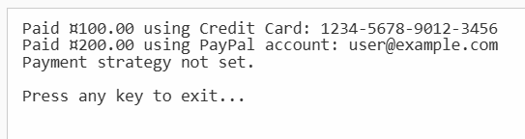

Exercise 9: Implementing the Command Pattern
Codes:
using System;

// Step 2: Define Command Interface
public interface ICommand
{
void Execute();
}
// Step 5: Implement Receiver Class
public class Light
{
public void On()
{
Console.WriteLine("Light is ON");
}
public void Off()
{
Console.WriteLine("Light is OFF");
}
}
// Step 3: Implement Concrete Commands
public class LightOnCommand : ICommand
{
private Light _light;
public LightOnCommand(Light light)
{
_light = light;
}
public void Execute()
{
_light.On();
}
}
public class LightOffCommand : ICommand
{
private Light _light;
public LightOffCommand(Light light)
{
_light = light;
}
public void Execute()
{
_light.Off();
}
}
// Step 4: Implement Invoker Class
public class RemoteControl
{
private ICommand _command;
public void SetCommand(ICommand command)
{
_command = command;
}
public void PressButton()
{
if (_command != null)
{
_command.Execute();
}
else
{
Console.WriteLine("No command assigned.");
}
}
}
// Step 6: Test the Command Implementation
class Program
{
static void Main(string[] args)
{
Light livingRoomLight = new Light();
ICommand lightOn = new LightOnCommand(livingRoomLight);
ICommand lightOff = new LightOffCommand(livingRoomLight);
RemoteControl remote = new RemoteControl();
// Turn light ON
remote.SetCommand(lightOn);
remote.PressButton();
// Turn light OFF
remote.SetCommand(lightOff);
remote.PressButton();
}
}

Output:
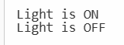

Exercise 10: Implementing the MVC Pattern
Codes:
using System;

// Step 2: Model Class
public class Student
{
public string Name { get; set; }
public int Id { get; set; }
public string Grade { get; set; }
}
// Step 3: View Class
public class StudentView
{
public void DisplayStudentDetails(Student student)
{
Console.WriteLine("Student Details:");
Console.WriteLine($"ID: {student.Id}");
Console.WriteLine($"Name: {student.Name}");
Console.WriteLine($"Grade: {student.Grade}");
}
}
// Step 4: Controller Class
public class StudentController
{
private Student _model;
private StudentView _view;
public StudentController(Student model, StudentView view)
{
_model = model;
_view = view;
}
public void SetStudentName(string name)
{
_model.Name = name;
}
public string GetStudentName()
{
return _model.Name;
}
public void SetStudentId(int id)
{
_model.Id = id;
}
public int GetStudentId()
{
return _model.Id;
}
public void SetStudentGrade(string grade)
{
_model.Grade = grade;
}
public string GetStudentGrade()
{
return _model.Grade;
}
public void UpdateView()
{
_view.DisplayStudentDetails(_model);
}
}
// Step 5: Test MVC Implementation
class Program
{
static void Main(string[] args)
{
// Create Model
Student student = new Student { Name = "Alice", Id = 101, Grade = "A" };
// Create View
StudentView view = new StudentView();
// Create Controller
StudentController controller = new StudentController(student, view);
// Display initial details
controller.UpdateView();
Console.WriteLine("\nUpdating student details...\n");
// Update student details via controller
controller.SetStudentName("Bob");
controller.SetStudentGrade("B+");
// Display updated details
controller.UpdateView();
}
}

Output:
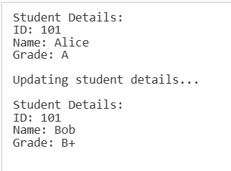

Exercise 11: Implementing Dependency Injection
Codes:
using System;

namespace DependencyInjectionExample
{
// Step 1: Define Repository Interface
public interface ICustomerRepository
{
Customer FindCustomerById(int id);
}
// Step 2: Implement Concrete Repository
public class CustomerRepositoryImpl : ICustomerRepository
{
public Customer FindCustomerById(int id)
{
// Simulating a customer lookup
if (id == 1)
{
return new Customer { Id = 1, Name = "John Doe", Email = "john.doe@example.com" };
}
else
{
return null; // Customer not found
}
}
}
// Model Class
public class Customer
{
public int Id { get; set; }
public string Name { get; set; }
public string Email { get; set; }
}
// Step 3: Define Service Class
public class CustomerService
{
private readonly ICustomerRepository _customerRepository;
// Step 4: Implement Dependency Injection via Constructor
public CustomerService(ICustomerRepository customerRepository)
{
_customerRepository = customerRepository;
}
public Customer GetCustomerById(int id)
{
return _customerRepository.FindCustomerById(id);
}
}
// Step 5: Test the Dependency Injection Implementation
class Program
{
static void Main(string[] args)
{
// Create an instance of the repository
ICustomerRepository customerRepository = new CustomerRepositoryImpl();
// Inject the repository into the service
CustomerService customerService = new CustomerService(customerRepository);
// Find a customer by ID
Customer customer = customerService.GetCustomerById(1);
// Display customer details
if (customer != null)
{
Console.WriteLine($"Customer ID: {customer.Id}");
Console.WriteLine($"Customer Name: {customer.Name}");
Console.WriteLine($"Customer Email: {customer.Email}");
}
else
{
Console.WriteLine("Customer not found.");
}
Console.WriteLine("\nPress any key to exit...");
Console.ReadKey();
}
}
}

Output:
